**Doubtful Loan at OBM is mismatch amount between Per GL and Per Listing:**

Contract LD: LD1605440939

Customer Name: HUN RA

Customer ID: 4000039298

Disburse Date: 20160223

Maturity Date: 20210218

Day Due: 196 Days

|  |  |  |  |
| --- | --- | --- | --- |
| Contract LD | Per GL | Per Listing | Diff. |
| LD1605440939 | 22,300.31 | 22,495.84 | 195.53 |

Per GL-CRB:

52210-Doubtful Loans – Short term Commercial Loans

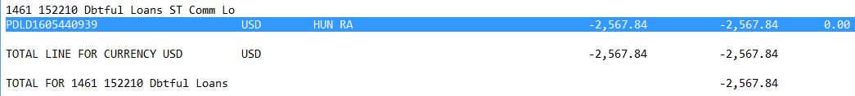

152370-Doubtful Loans – Other Long term Loans Private Sector - Resident

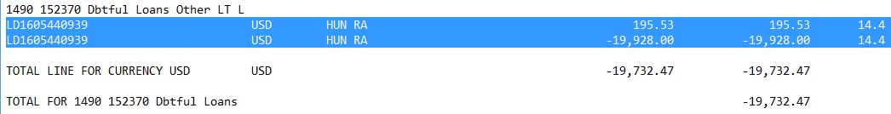

Per Listing Report:

